MODULE 3

VIDEO LESSON 2- INSTAGRAM

WORKSHEET

Summary:

Instagram is another very popular social media platform.

Currently, worldwide, the statistics on users by platform are as follows:

Facebook 2.4 BILLION
YouTube 2 BILLION
Instagram 1 BILLION
Twitter 330 MILLION
LinkedIn 250 MILLION
Snapchat 210 MILLION

In this Marketing Bootcamp, we’re focussing on Facebook because the most people use it (and in case you want to use it for paid ads later – it’s super sophisticated in its targeting capabilities), Instagram, because you can reach a lot of people if you know how to use the hashtags properly (#), and LinkedIn, because you can proactively search for and reach out to your ideal client, connect with them, and in a nice and polite way, sell to them.

Instagram is a very visual platform, and is all about imagery.

Personally, I don’t spend any time at this point, creating separate content for each social platform. I honestly believe that right now, that is not where our time would be spent best - unless you really want to, but I want to show you how you can still get your marketing practices up to speed with the least amount of effort!

The main thing about Instagram is to share appealing images (by the same token, I recommend doing this for Facebook and LinkedIn, too, it just helps get people’s attention).

You can apply a filter to enhance the image if you like, add a caption, as well as up to 30 hashtags (#), which act as a kind of search tool. Users are able to “follow” certain hashtags they are interested in, and you’ll be surprised to see that not just foodies or lifestyle influencers use Instagram!

Similarly to Facebook profiles, you can set up your profile to clearly communicate to your ideal client what you do, and you can include one URL as well, for example to your website or your free downloadable PDF, etc. When they visit your profile, they’ll know exactly what you’re about and, if they’re interested, they can take the first step to entering your world.

What you need to know about the Hashtags:

- You can use up to 30 hashtags per Instagram post – there are many different theories around what is the best number, but from my experience I still find the reach the posts get for me is best when I use as many as I can.
- Use the #’s to describe what’s in the photo, but you can also get a bit creative and abstract and use ones that bring the context back to your business, so you can reach people who would be your target market and not just people interested in that particular image. For example, in the breakfast post below, if it had been a meeting with a client, I could have included #clientmeeting #meeting #client #strategysession, etc.
- Because Facebook owns Instagram, they have an integrated function with which you can simultaneously share your Instagram posts to your business page. This is a great feature, HOWEVER if you want to use it, don’t include the #’s in the body of the caption (text under the image). Rather, simply post the image itself, and then go to the live post and put your #’s in the first COMMENT underneath the post. The reason this is important to know is because while Instagram thrives on #’s, Facebook will deem any post with more than 2-3 #’s as “Overly Promotional” and, because they ultimately want you to pay for advertising, will limit that post’s reach.

Here is an example of how to create a post in Instagram:

- Within the Instagram app, tap on the + icon at the bottom of the screen.
- Select the photo you wish to share and tap “Next”
- Select a filter to enhance your photo (optional) and tap “Next”
- Write a relevant caption, tap “Next”
- Under the live post, tap the “Comment” icon and enter all your hashtags, then tap “post”

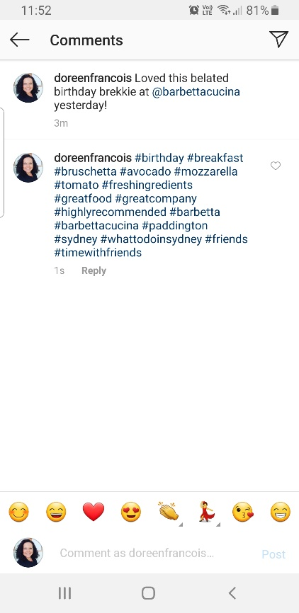
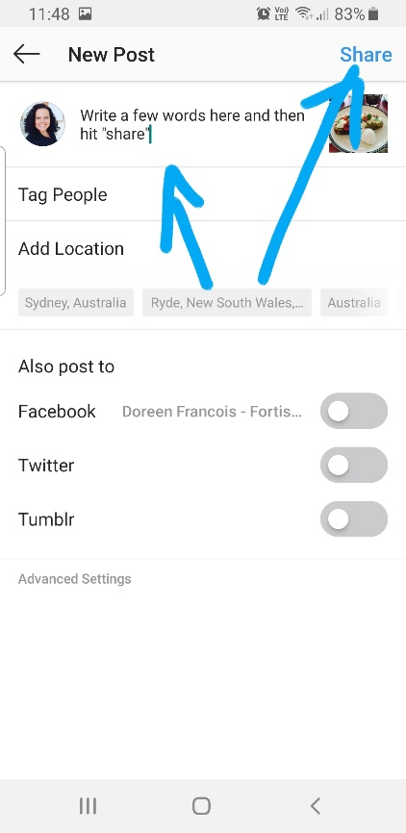
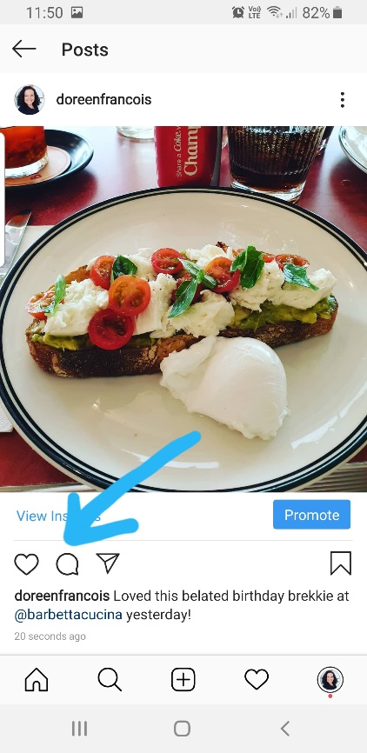
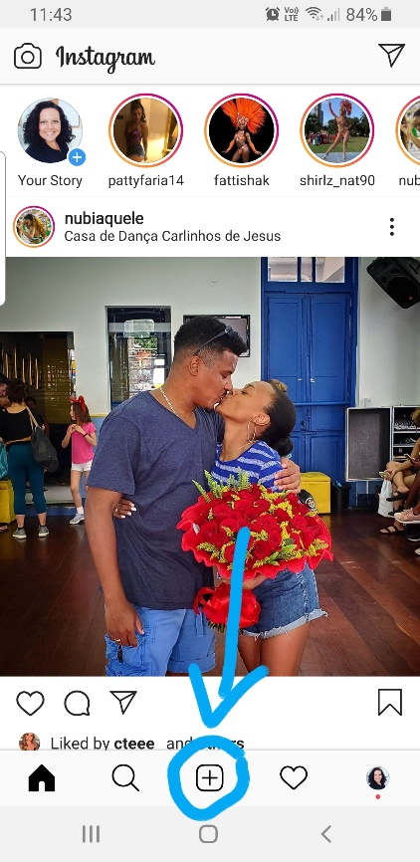
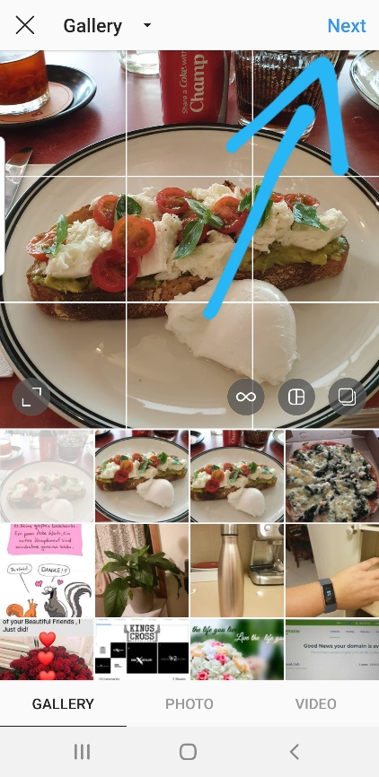
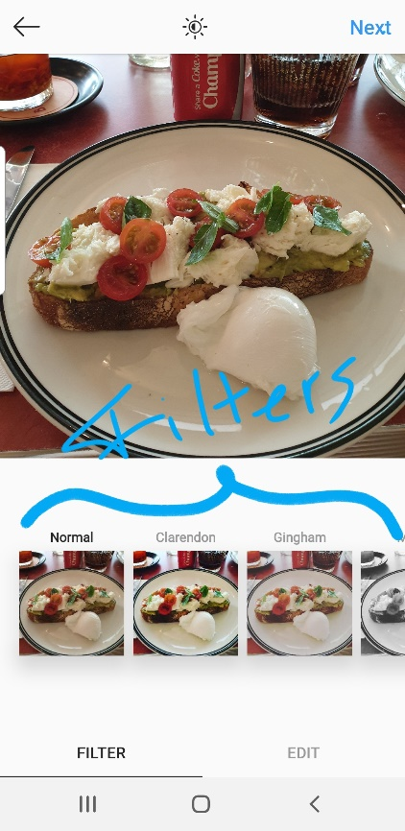

Action Items:

- If you don’t have one already, create a business Instagram account.

- Set up your profile by clearly communicating whom you help and what you help them with.Include a link to your website or any other relevant URL.

