MODULE 5

VIDEO 3– LINKEDIN PART VI

WORKSHEET

Summary:

Today, you’re going to be drafting your final messages for your LinkedIn Lead Generation messaging sequence.

This includes your actual “sales” message (but I call it an “Intro message), and then the email you send once they request more information.

Keep the sales message as short as you can, meaning: DO tell your FULL story but as concisely as humanly possible. Also, make sure you keep a conversational tone, this will help to humanise you to the reader, and build trust.

I’m going to share my “magic message” with you in a moment, which actually helped me generate over 115 leads in 4 days!

To give you a bit of a back story to this:

I was in a place at the time, in which I desperately needed to make something happen in my business – FAST! My back was against the wall, and I was trying to come up with a way of reaching out to as many people as possible, to build momentum back up, and hopefully quickly.

I figured, there must surely be a way in which I could reach out to my existing LinkedIn connections, and “sell” to them, without p*issing them off, right?!

So, while I pondered this notion, I actually downloaded an archive of my existing connections from LinkedIn. Which, by the way, if you wanted to do this, too, here’s how you do it:

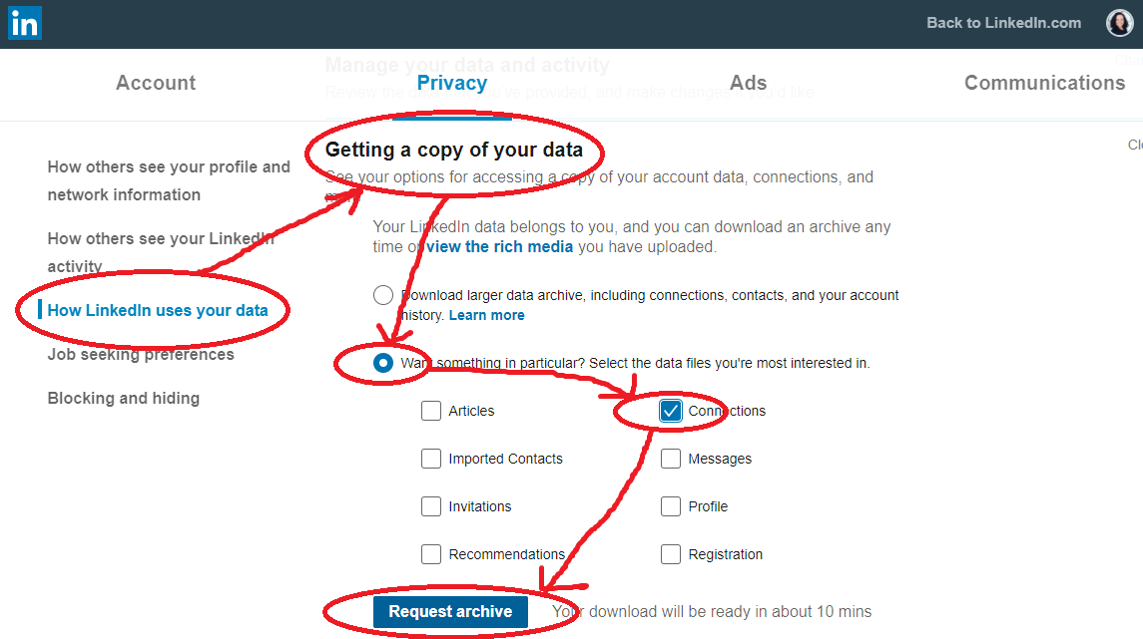

Once you hit “Request Archive”, LinkedIn will email you with a link which will take you back to that page but you’ll see a “Download” button, where you can download the CSV file.

Please note, the above is completely OPTIONAL for the purpose of this Bootcamp, but if you have a lot of people in your network whom you believe could be your target market and you wanted to send your “Intro” message to, by all means, go for it!

So, back to my story…

Once I’d downloaded my archive, I went through my connections and deleted anyone I didn’t believe to be my Ideal Client. This left me with about 2000 contacts to message.

I then drafted my “Intro” message. Once done, I waited for a day just to make sure I was still happy with it, and when I realised that I was, I proceeded to send it to the 2000-odd people on that database!

It took me 4 full days of manually copying and pasting my “Intro” message (because we don’t do automation here unless we want to end up in LinkedIn Jail!), but the resulting 100+ leads that came from it absolutely made it worthwhile and in fact, it was this that ended up turning my business around again!

So, without further ado, here is my original “Intro” message. Feel free to adjust it to suit your business and your tone of voice, and make it your own:

“Hi NAME,

I hope your week is treating you well!

Please excuse the cold outreach - I felt I should get in touch and introduce myself properly, because we connected here on LinkedIn a little while ago.

I run a company called Fortissimo Marketing; in a VERY small nutshell, we provide Done-For-You marketing, as well as marketing training/mentoring, specialising in helping businesses within the industrial sector.

You probably have this area of your business covered already, either by having to do it all yourself, or by internal staff members, or you might be working together with an agency or freelancer.

My intention isn’t to tell you “use us, not them”, my purpose is simply to let you know we exist, so if at any point in the future you have a need for what we do, you know who we are!

If you’d like me to send through some more information, just let me know your best email and I’ll be happy to send you our company brochure for some light reading. :)

If not, no offense taken!

In any case, have a great day further and hopefully we’ll speak in person sometime in the future.

Many kind regards,
Doreen.”

Once people started responding with their email addresses, I would send them an email, attaching my company profile for them.

The subject line I just kept really simple: “Fortissimo Marketing Information”

In the body of the email, I would write this:

“Hi NAME,
Thank you very much for your interest. As promised, please find attached our company brochure.

If you would like to discuss this further or if you have any questions, I’d be happy to arrange a time to chat on the phone or face to face.

In the meantime, wishing you a great rest of the week, and I hope to speak with you again soon!

Best regards,
Doreen.”

The key here is to come up with a friendly email template which you can just copy and paste, to save yourself from having to type each email from scratch.

So, you now have my entire LinkedIn system and can implement all of this for yourself, too!

From here on, you will need to continue your usual sales follow-ups to get your new clients on board.

We’ll be going over all of this at a later date as well, but for now, you’re all set up to generate leads on LinkedIn and respond to them!

Action Items:

- Draft your own “Intro” message

- Draft your own “Info” email message

- Send your “Intro” message to your connections 1 week after your initial “Hello” message, and once new leads start coming in, send them your information in an email. (Make sure you keep track of your leads either in your CRM or your Excel spreadsheet, so you can follow up!)

- OPTIONAL: Download an archive of your existing LinkedIn connections, delete anyone who is not relevant from the spreadsheet and send your “Intro” message to all the rest!

