MODULE 8

VIDEO 3– LEAD MAGNET DISTRIBUTION

WORKSHEET

Summary:

The final step for your lead magnet, is for you to integrate it into your website.

This might be a bit of a tricky one for you, and unfortunately, I am not able to be more specific with instructions due to the fact that there are so many variables in website platforms and email auto-responders out there.

You’ll either be doing this yourself, or have your web developer do this for you.

If you do get stuck, please reach out and I’ll help as much as I can!

You’ll have to create a new page within your site, where you will be offering (but also selling) your lead magnet.

Yes, although we know how valuable our information would be to anybody downloading it, it’s amazing how much you actually do have to “sell” people on doing so these days, because they fear they’ll be bombarded with tons of marketing emails afterwards!

And yes, there will be some follow-ups from us as well eventually, but we won’t be continuously spamming them.

To help you with this, once again I’m happy for you to use my own page as a template and adjust the content to reflect what you’re offering: www.fortissimo.com.au/5dframework

You will also have to include a form and create an auto-responder email in which you deliver the lead magnet.

Here is the process we are currently using, which integrates our emailing platform MAILCHIMP with our website:

- The Fortissimo website is built on Wix, and we use an app called “Contact Collection” on the actual page.

- In the settings of the Contact Collection app, we connect the app with our Mailchimp account.

- In Mailchimp, we have an audience called “5D Framework Downloads”, so any new subscribers are immediately added there.

- We also have an automated email (the “5D Framework Autoresponder”) that is triggered immediately when a new subscriber is added to this audience:

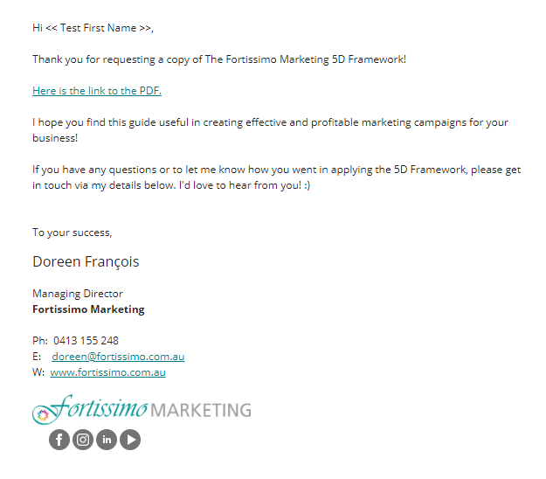
- The actual PDF is uploaded to Mailchimp and the link in the body of the email directs back to that document, which is how the reader can access it.

Action Items:

- Add the lead magnet to your website or have your web developer do this for you, by adding a new page to your website.

- Write a “sales letter” for your lead magnet (use the example provided if you get stuck).

- Set up an autoresponder to deliver your lead magnet.

