WEEK 6

VIDEO MODULE 2 – CONTENT CREATION

WORKSHEET

Summary:

Today, we are going to create your actual posts!

A few general tips:

- Contrary to regular/academic writing, paragraphs more than 1 sentence can become too much text on the screen, and can deter people from reading your post. Break up the text by adding a line in between each sentence, making it easier on the eye.

- Add an image to support your posts wherever you can, this helps with catching the reader’s eye and getting them to stop scrolling.

- Use emojis (the smiley faces etc. on your phone) – for some reason the algorithms love this and again it helps with getting the reader’s attention.

- Not every post has to be an essay! Mix it up by making some longer posts, and some shorter.

- Avoid putting your website URL in the body of the text whenever possible – the social platforms want to keep the users on their site for as long as possible, so they will limit the amount of people that will see posts with external links.

- Keep the tone of your posts conversational, like you’re having a conversation with a single person.

If you’re stuck for ideas, below are some examples of my own posts for each category. Feel free to plagiarise this as you wish! 😉

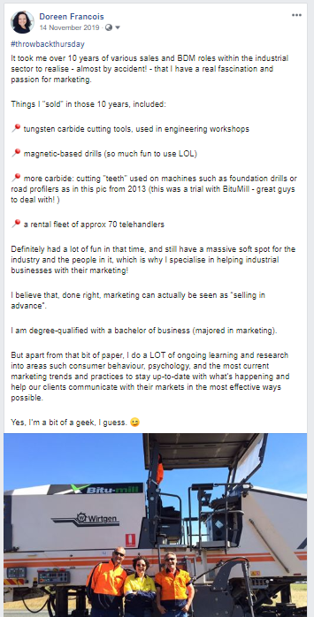
Examples of “Educational” Posts

Examples of “Why I Love What I Do” Posts
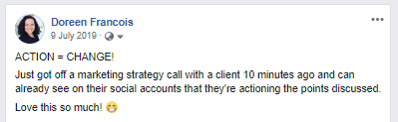

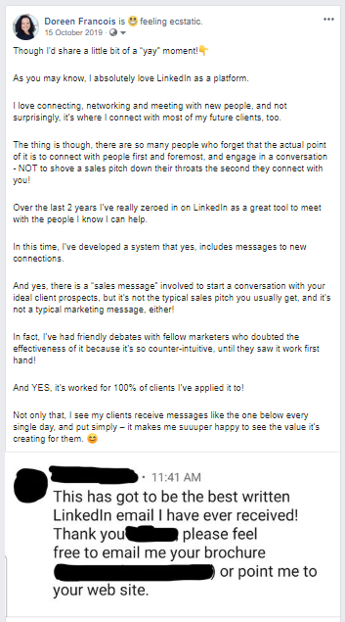

Examples of “Behind The Scenes” Posts
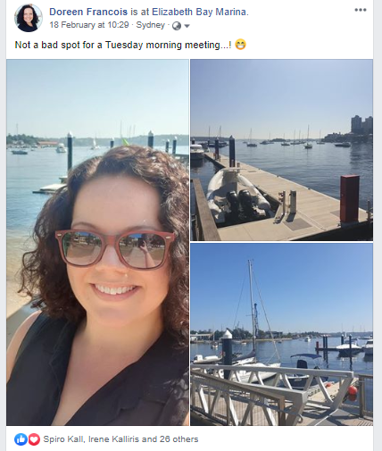

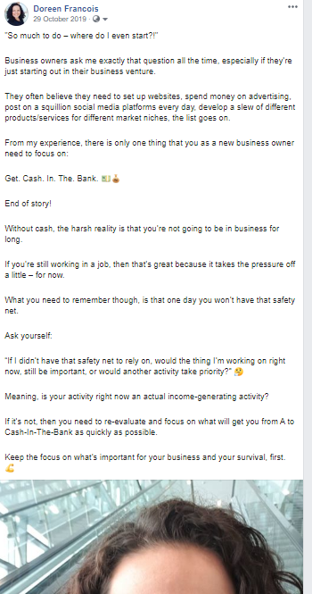
Examples of “Value” Posts
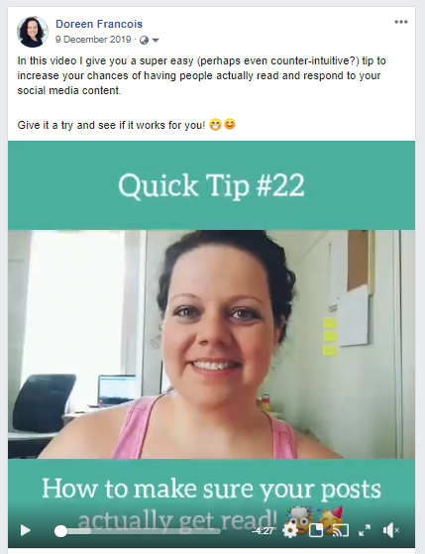

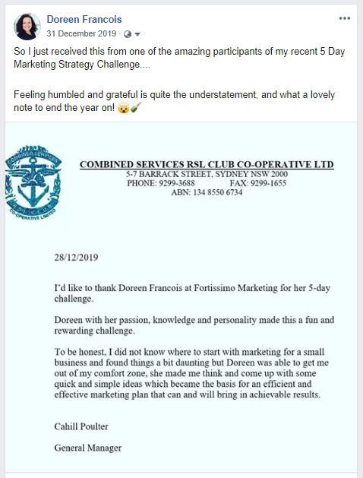
Examples of “Social Proof Posts”

Examples of “Sales” Posts
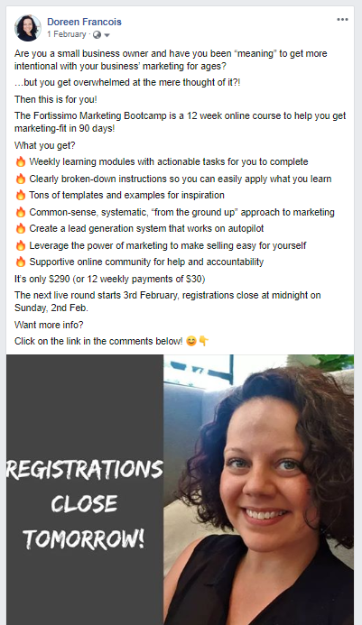
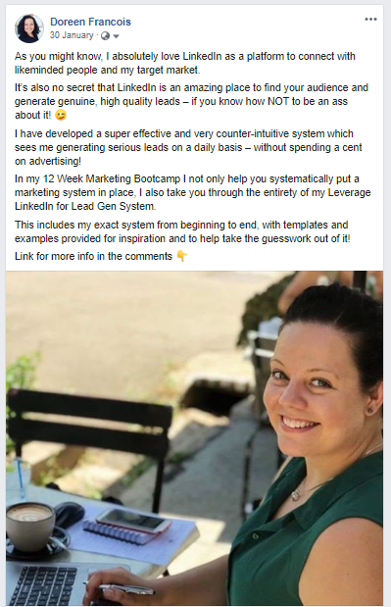

Our aim here is not necessarily to become copywriting experts overnight – our aim is to get it done because imperfect action beats perfect inaction every time, and DONE is much better than PERFECT!

I’ve also provided a template online, which you can download below the icon for this worksheet. You can use this to organize your posts in the one place.

Action Items:

- Write your 12 social media posts, using the template and example posts provided.

