WEEK 4

VIDEO MODULE 1 – LINKEDIN PART I

WORKSHEET

Summary:

This week we’re going to start getting into my favourite social media platform of all – LinkedIn!

It’s a common misconception that you have to be in the Business-to-Business selling space to have success on LinkedIn.

The thing is, if you did the exercise on your Ideal Client Avatar in week 2, you would know what your ideal client does for work, meaning you can most definitely find them on LinkedIn!

As a first step though, we need to make sure your own profile is up to date. So if you don’t have a LinkedIn profile yet, please register one now.

There are a few things to do to make sure you’re representing yourself in the best possible way on LinkedIn…

Firstly, make sure your profile picture is a photo of YOU! Not your business’ logo, not a product you make, not a family photo – it needs to be a clear, current photo of yourself. Yes, you can take a “selfie” if you don’t have an adequate photo you can use, just try and angle the phone in a way that doesn’t make it look too much like a selfie. 😉
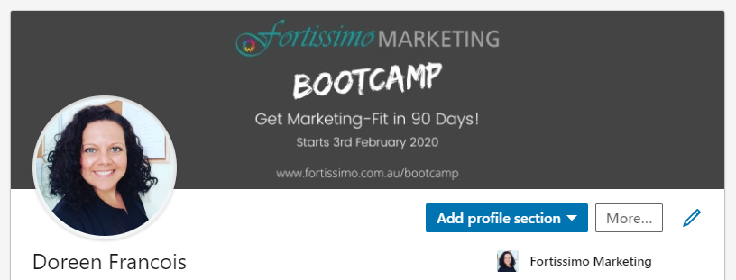

Next, check your work history and make sure it is up to date as well. You’ll find this if you go to your personal profile and scroll down to the “Experience” section.

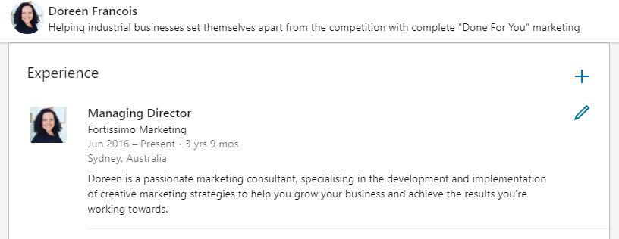

If you don’t have a business page on LinkedIn, I would recommend you set one up and add your company logo as its profile picture.

We’re not going to be worrying too much about the business page itself at this stage because just like Facebook, the company page gets very little reach and on LinkedIn specifically, communicating to your personal network directly is FAR more effective. But you’ll see that you can link your work history to that business page, which will then show up with your logo/image on your personal page, which looks much more professional than the blank, grey box, which will be there, otherwise.
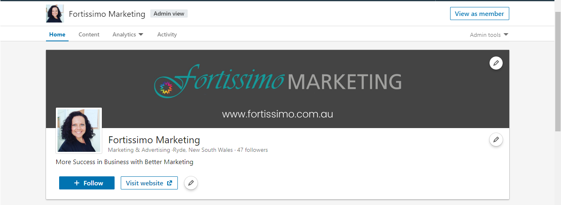

Next, update your LinkedIn URL. This is a tiny adjustment and again just a “best practice thing”, but it just looks good!

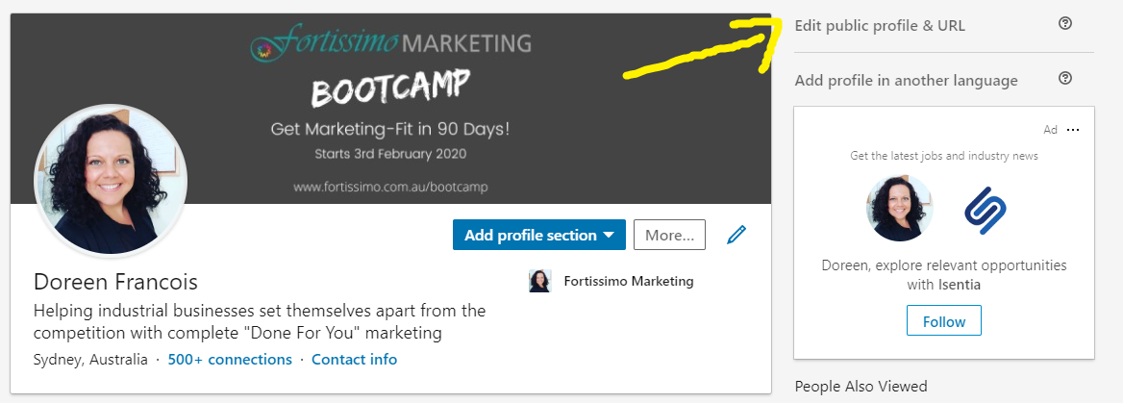

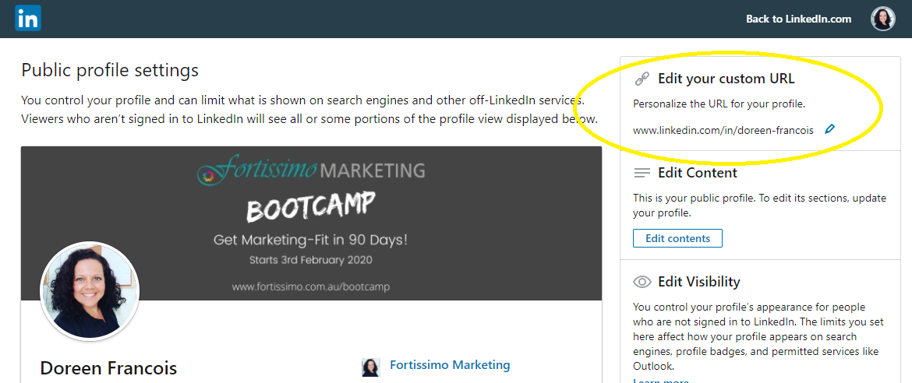

If you’ve not done this before, you’ll notice a bunch of random numbers behind your name. Tidy this up as best you can. The benefit of doing this is that you can easily remember your URL and you can include it in your marketing material, too. It just looks neater, cleaner, more professional.

And finally, the last step for today is for you to update your Headline.

The formula I like to use here is one I learned from Helen Pritchard, a LinkedIn expert whom I’ve been following for a number of years.

The reason the Headline is so important is because this is literally the first thing your connections see when they see you on LinkedIn! You can either just put down your job title, which many people do, or you can intentionally leverage this space to send a very clear message to anyone checking out your profile.

The formula is as follows:

Helping [your ideal client] [solve their problem] by [how you do it].

For example, my headline reads: “Helping industrial businesses set themselves apart from the competition with complete Done-for-You Marketing”.

I regularly have prospective clients tell me that the thing that got their attention on LinkedIn was that I specialize in “industrial” businesses – a clear example of how you can communicate with your ideal client and make them realise you understand them!

Action Items:

- Make sure your profile pic is a current, clear photo of yourself, add a relevant banner image to your personal profile.

- If you don’t have a LinkedIn business page, create one.

- Check that your work history is up to date, link your business page to your current role

- Edit your profile URL

- Compose a new Headline using the formula Helping [your ideal client] [solve their problem] by [how you do it].

_____________________________________________________________________________________

_____________________________________________________________________________________

_____________________________________________________________________________________

