WEEK 4

VIDEO MODULE 2 – LINKEDIN PART II

WORKSHEET

Summary:

Today, we will be re-vamping the Summary on your personal LinkedIn profile.

What a lot of people do is use this space to talk about themselves, their education, accomplishments, etc.

Unfortunately for us, nobody really cares about us as much as what we might think!

So again, following in my Guru’s (Helen Pritchard’s) footsteps, we’re going to craft our Summary in a way that makes it all about the person reading it!

Inadvertently, it is going to become a kind of landing page, or sales page. We’re going to make it all about the person reading it, get them engaged, explain how we can help solve their problems, and give them the opportunity to contact us.

The way I break down the Summary is as follows:

- We start by asking a few qualifying questions that your ideal client would identify with.
- We explain what we do, and what makes us different, compared to others.
- We end with a call to action and provide our contact details.
- We upload supporting media such as brochures, testimonials, photos and/or videos.

Here is my own summary, which you are welcome to use as a template (just make sure you make it sound like you!):

[SECTION 1 – QUALIFYING QUESTIONS]

“Are you a business owner wanting to grow your business and increase your revenue without increasing your workload?
Do you have a list as long as your arm of marketing activities you know you *should* be doing but don’t even know where to start with it?
Would you like to have someone work with you, who is 100% in your corner but with a fresh set of eyes to help you develop a killer marketing strategy that will help you achieve your goals?
And from there, would you like this person to just get it all done for you, so you don't even have to worry about it anymore?!
[SECTION 2 – ABOUT ME]
I am a super-passionate marketing strategist, and I love nothing more than to help other business owners grow their client base with creative strategies that will convey their message to their market in the most effective way - and really set them apart from the competition!
With over 14 years of experience in various sales and BDM roles within the industrial sector, I still have a big soft spot for "the industry" and specialise in helping industrial businesses develop and implement killer marketing strategies.
My background in sales has equipped me with a very practical and results-oriented approach to marketing, and I believe that marketing should always generate and ROI for your business.
If it's not - then something isn't working and needs to be reassessed!
I am not for everyone – I have a no fluff and no BS approach to marketing, so if you have an open mind towards implementing new ideas, then I can help you.
I see my clients’ subsequent success as my very own responsibility and will not rest until they get results.
[SECTION 3 – CALL TO ACTION]
You can either try to keep doing it all yourself, with the same outcomes, or take the next step and get in touch with me to help you grow your business – and have a great time along the way! :)
e: doreen@fortissimo.com.au
w: fortissimo.com.au
w: facebook.com/groups/fortissimomarketing
P.S. You can download my FREE 5D Framework eBook here: www.fortissimo.com.au/5dframework
P.P.S. If you'd like to book in for a free 30 minute marketing audit, you're welcome to do so here: www.fortissimo.com.au/free-marketing-audit”

As you can see, I’ve also uploaded screenshots of testimonials to support. Testimonials and reviews are really important “social proof” which tells your audience that you can do what you say you can do, and helps sway them in favour of working with you.

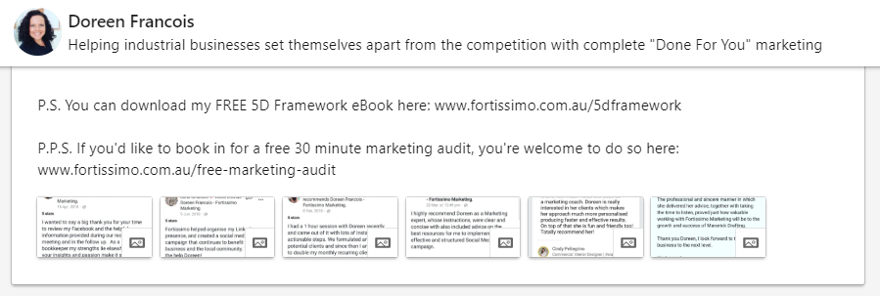

Action Items:

- Write summary according to sales page structure.

- Upload supportive media (optional)

