

**WEEK 10**

VIDEO MODULE 3 – THE SALES FUNNEL

WORKSHEET

Summary:

Back in the very beginning of this bootcamp, we discussed and set goals for ourselves and our businesses.

How are you going with those right now? Are you on track?

If you’re finding you’re not entirely where you wanted to be when you first set your financial goals, then today we’re going to work out and calculate exactly what you need to make sure you achieve them, by understanding your sales funnel.

A sales funnel basically just means that there is a process from originally coming “into your world” to then doing business with you, and as your prospects move through this process, some of them decide not to purchase, and drop off.

Therefore, the number of people who end up buying is much lower than the number of people who originally express their interest (hence the visual representation by a funnel).

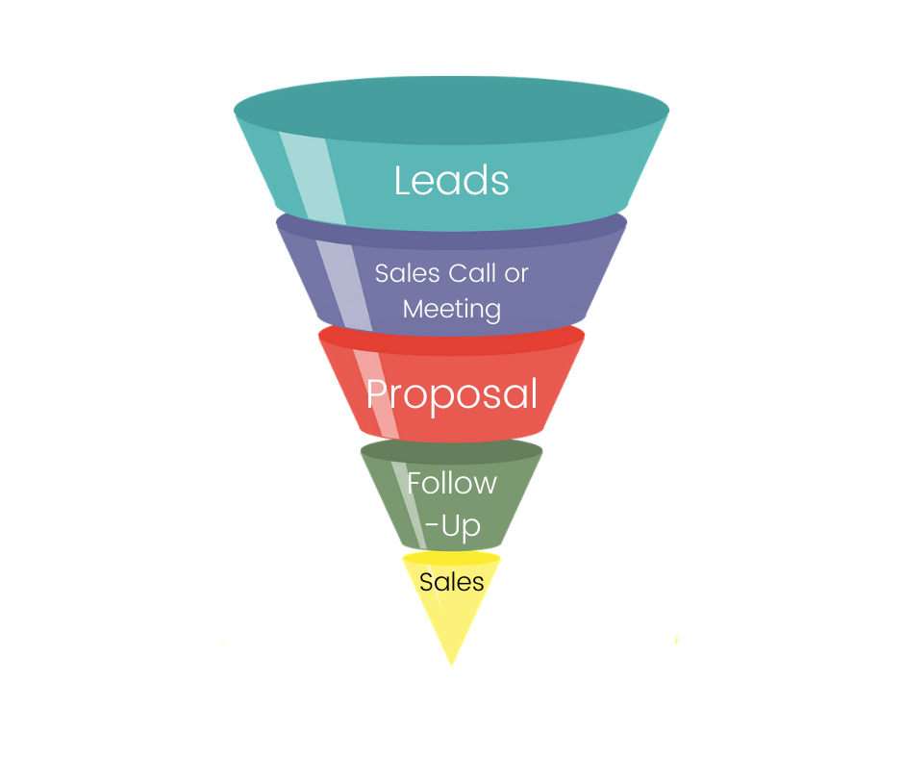

This is perfectly normal!

We first need to understand, though, how much each sale is worth to us (on average), and how many sales we would need to achieve our financial goal.

We also need to understand that in order for us to have X amount of people buy from us, we need to have many more coming into our “funnel” in the first place. More activity at the top of our funnel, will ultimately result in more sales.

Sales is, indeed, a numbers game!

As a basic rule of thumb, multiply each main step of your sales cycle by 10.

For example, your main steps could be:

1. Lead in
2. Proposal
3. Sale

For if for every sale you want to make, you have to submit 10 proposals, but only 1 in 10 leads get to the proposal stage in the first place, this means you need to get 100 leads in to get 1 sale.

So based on these numbers… how many leads do YOU need to get the amount of sales you want?

Action Items:

1. Calculate how many leads you need to achieve your sales target by reverse engineering your financial goal according to the sales funnel rule of thumb.

______________________________________________________________________________

______________________________________________________________________________

1. Brainstorm 3 areas where you might find more leads/prospects to add to the top of your funnel.

______________________________________________________________________________

______________________________________________________________________________

______________________________________________________________________________