WEEK 5

VIDEO MODULE 1 – LINKEDIN PART IV

WORKSHEET

Summary:

Welcome to the next step in my LinkedIn Lead Generation System!

Today, we’re going to start reaching out to your new connections on LinkedIn. The easiest way to do this is to click on “My Network” at the top of your Home screen in LinkedIn, then Click on “Connections”.

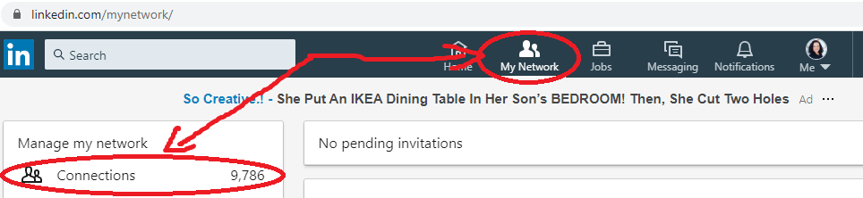

You’ll then see all your connections displayed in chronological order, with your newest connection at the top of the screen.

Your next step is to send all your new connections what I call a “Hello” message. Just to say hi and thank them for connecting with you.

Choose something reasonably short and simple, and feel free to add a little bit of your own flair to it!

IMPORTANT: Do not get tempted to pitch or include any form of call to action, your website URL or talk about yourself in any way!

Examples of “Hello” messages:

“Hi NAME,
Thanks for connecting, I hope you’re having a great week so far!

Cheers,
YOUR NAME”

or

“Hi NAME,
Thanks for connecting, great to e-meet you.
Hope your week is treating you well!

Best regards,
YOUR NAME”

or (and this is the one I use because it reflects my personality)

“Hi NAME,
Thanks for connecting, nice to e-meet you. :)
I just wanted to drop you a quick line because I didn’t want to be one of those people who connect and never say hello!

Have a great day,
Doreen.”

Next, we need to make sure we keep track of all these new connections, and mark them with the dates for the next round of messages.

You can either use a CRM if you’re already using one, or just use a simple spreadsheet, like this:

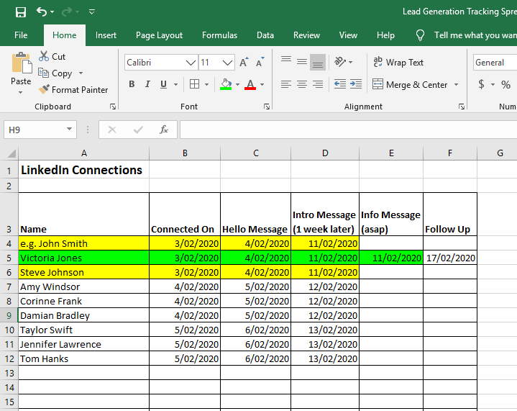

If you’d like to use an Excel Spreadsheet for now, you’re welcome to download the above template from the website (it’s right below this worksheet).

Action Items:

- Draft your own “Hello” message

- Send it to your new connections – make this a daily habit.

- Decide on how you will be tracking your new connections – CRM or Excel, and enter your new connections into your database. Make a note of the date one week from the date on which you sent your “Hello” message, which is when you’ll be sending the next message out.

