WEEK 6

VIDEO MODULE 3 – INTRODUCTION TO CANVA

WORKSHEET

Summary:

Have you ever wondered how people create those professional-looking images online?

The initial assumption is obviously that they’d have a graphic designer involved, or at least someone who knows how to work Photoshop – and unfortunately, both of these options can be quite expensive, time consuming and complicated.

But fear not – there is another much easier way to get some great looking posts happening, which won’t kill your budget, and as long as you’re willing to give it a bit of a go, you’ll get some great results from it, and can make you look really professional!

I’m talking about the ingenious cloud-based program called Canva.

Canva is essentially “photoshop for dummies” (meaning it’s perfect for me LOL).

I’m not a graphic designer, nor do I employ a graphic designer at this stage except for specific client projects, but Canva allows my team and I to create eye-catching imagery for our socials, website, newsletters, flyers, etc.

Even the headers on these worksheets we created using Canva.

The best thing about it: it’s FREE!

As with anything, there is obviously a paid version as well but really, the free version already does a LOT and is definitely sufficient. Apart from one occasion where I signed up for their free premium trial (I wanted to remove the background of an infographic I was creating), we’ve so far never had a need for the paid subscription!

Here are some examples of what I’ve used Canva for:

Our Bootcamp Facebook Group’s cover image:
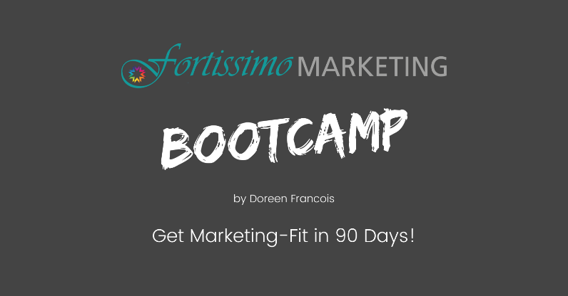

Social Media Posts

Infographics
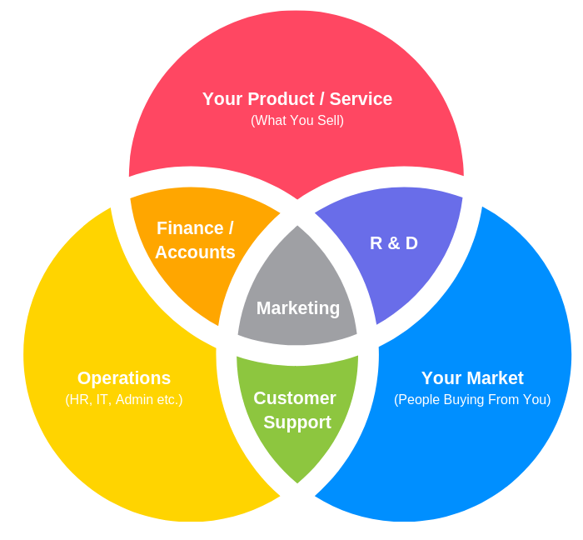
There are TONS of templates you can work with on there, the only limits you really have are your creativity, so go have a look at it for yourself!

(Fun fact: Canva is actually an Australian company based in Sydney, and after only a few years in business since 2012 is now valued at $3.2 BILLION!)

Action Items:

- Create a free Canva account at www.canva.com .

- Create an image for your social media using Canva and download it.

